ИИН: 900324400541
Телефон: 87788534583

БЕГАЛИЕВА Жадра Даулетовна,
№28 Абылайхан атындағы жалпы орта мектебінің ағылшын тілі пәні мұғалімі.
Түркістан облысы, Сарыағаш ауданы

MY COUNTRY A CITY PARK

Learning objectives(s) that this lesson is contributing to | 6.1.1.1 Use speaking and listening skills to solve problems creatively and cooperatively in groups;  6.3.1.1 Provide basic information about themselves and others at sentence level on an increasing range of general topics;  6.4.7.1 Recognise typical features at word, sentence and text level in a limited range of written genres;  6.5.1.1 Plan, write, edit and proofread work at text level with support on a limited range of general and curricular topics.
Lessonobjectives | Learners will be able to: Recognize new vocabulary words and can talk about people they like;  Identify a text about sightseeing in sentences with comparatives and superlative adjectives;  Develop their reading, speaking and writing skills.
Lesson plan
Planned timings | Teacher'sactions | Students` actions | Assessment | Resources
10 minutes | ORGANISATION MOMENT:  Teacher greets students  Teacher: Good morning!  How are you?  Learners answer the question ‘How are you?’  Welcome to our English lesson  Ok, if you are ready let’s start our lesson  Dividing into groups   | Students respond to greeting and take their places  Students come to the blackboard and say their best wishes to each other  Descriptor:  -choose one of these icons  -find your place by the method of ‘HIDDEN GROUP’ | Formative assessment  By the method of “Thumb”    ‘excellent’  ‘well done’  ‘good job’ | Books  Copybooks  Work sheet  Students book
25 minutes  10 minutes | MAIN PART  Let’s watch the video  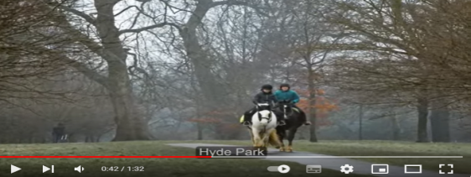  New words:  Lung-ӨкпеRelax-Босаңсу  Grand colonnade-Үлкен колоннада  Away-Алыста Neighborhood-Көршілестік  Pollution-ЛастануImpressive-Әсерлі  Traffic-ТрафикPath-Жол  Honor-ҚұрметHabitat-Тіршілікортасы  Spruce-Шырша Spectacular-Керемет  Escape-Қашу Annual-Жылдық  Listening  Group work    Writing  Group work  Exercise 1  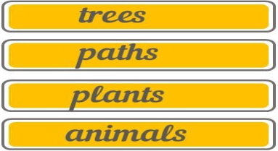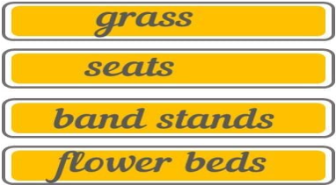  Speaking  Group work  Exercise 2    Grammar  We use comparatives and superlatives to say how people or things are different. We use a comparative adjective to express how two people or things are different, and we use a superlative adjective to show how one person or thing is different to all the others of its kind.  Writing  Exercise 3  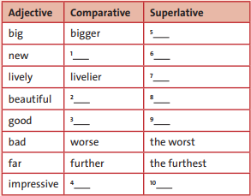  Reading  Group work  Exercise 4  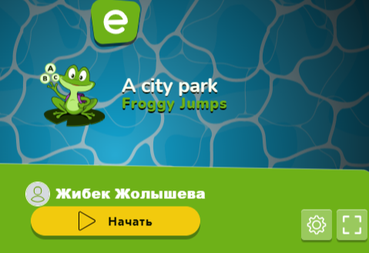  Speaking  Individual work  Exercise 5  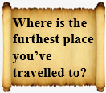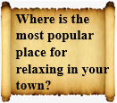  ENDING THE LESSON:  Well what did we do in our lesson?  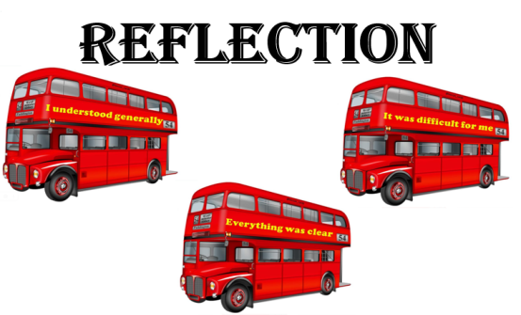  Evaluation of the lesson  Give the home task  Read about six sentences comparing your life with your friend using the grammar. Present it to class.  Say Good bye | Pupils should watch the video to recognize the theme  Descriptor:  -listen to and repeat after the teacher  -learn by heart the new words by the method of ‘SUITCASE’  Descriptor:  -listen to the recorder  -describe, explain and analyze the text by the method of  ‘DEAL’  Descriptor:  -read the words attentively  -write them to the right column by the method of  ‘THINNK TOGETHER’  Descriptor:  -read the sentences in candies  -put into the right pumpkin by the method of  ‘PUMPKIN SWEETS’  Learners should give attention to the screen and listen to the teacher to understand the grammar better and give some examples  Descriptor:  -look through the text  -complete the table with blue words from the text by the method of  ‘THINK, FIND and SEEK’  Descriptor:  -read the sentences  -complete them choosing the best variant by the method of ‘THINK TOGETHER’  Descriptor:  -choose any of these messages  -read and answer the questions by the method of ‘MESSAGE’  answer to some questions to know how they understand the lesson  Pupils tell the class if they understand today’s lesson  If they don’t understand they write it to the stickers and leave it to class  Learners should write the continuous of the sentences  Children say Good bye | Formative assessment  By the method of ‘COMPLIMENTS’  ‘EXCELLENT’  ‘WONDERFUL’  ‘GOOD TRY’  Formative assessment  By the method of ‘COMPLIMENTS’  ‘EXCELLENT’  ‘WONDERFUL’  ‘GOOD TRY’  ‘brilliant’  ‘good job’  ‘very well’  Formative assessment:  By the method of  1-2 points  Formative assessment:  By the method of  1-2 points  By the method of ‘COMPLIMENTS’  ‘brilliant’  ‘good job’  ‘very well’  Formative assessment  By the method of  1-2 points  By the method of  1-2 points  By the method of  1-2 points  Feedback  By the method of ‘COMPLIMENTS’  ‘brilliant’  ‘good job’  ‘very well’  ‘EXCELLENT’  ‘WONDERFUL’  ‘GOOD JOB’ | https://youtu.be/TI0ZLlvUti4?si=uSmiBegNxkvt4iNu  Flashcards  Students book  https://youtu.be/F3P47cH7wg8?si=buJNmo7Xrgy-MnDw  Projector  Cards  Pupil’s book  Cards  Board  Students book  Stickers  https://www.educaplay.com/learning-resources/18542773-a_city_park.html  Mobile phone.

